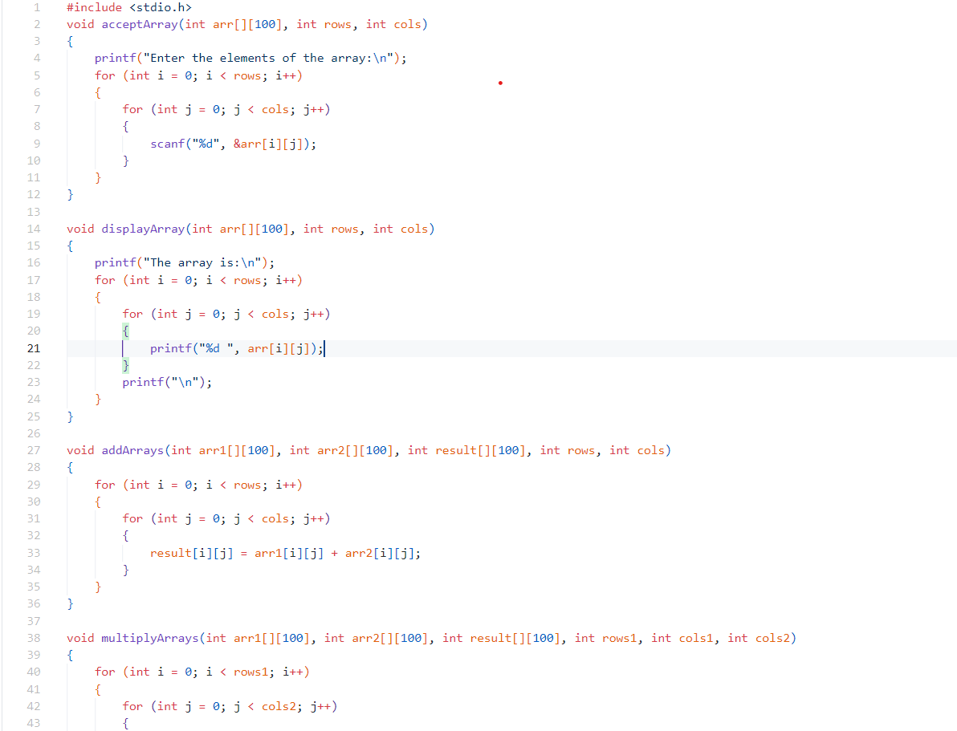

**Assignment 1: To Implement addition, multiplication and transpose of two 2D arrays**

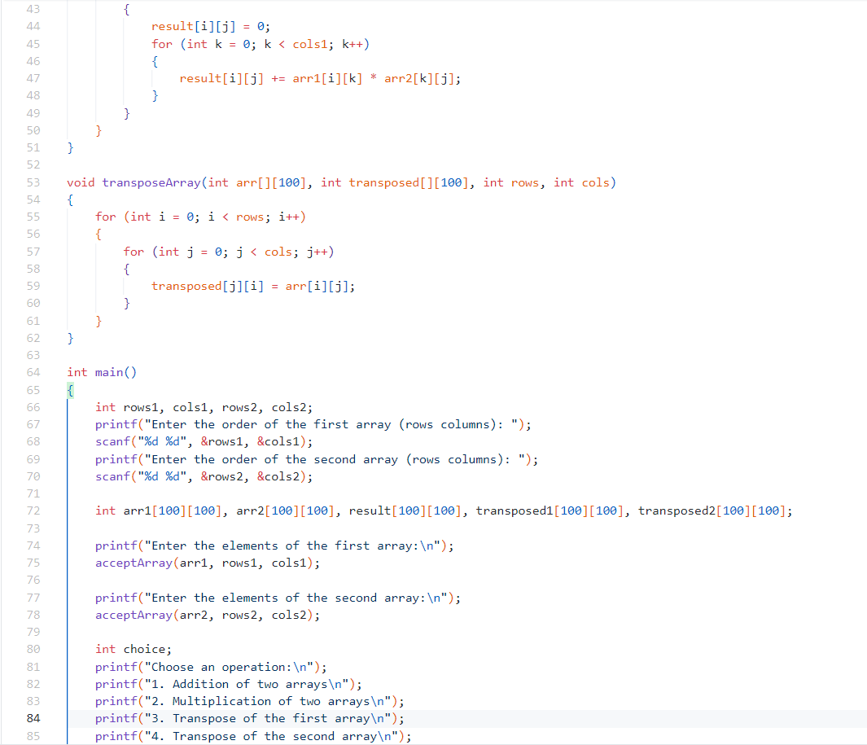

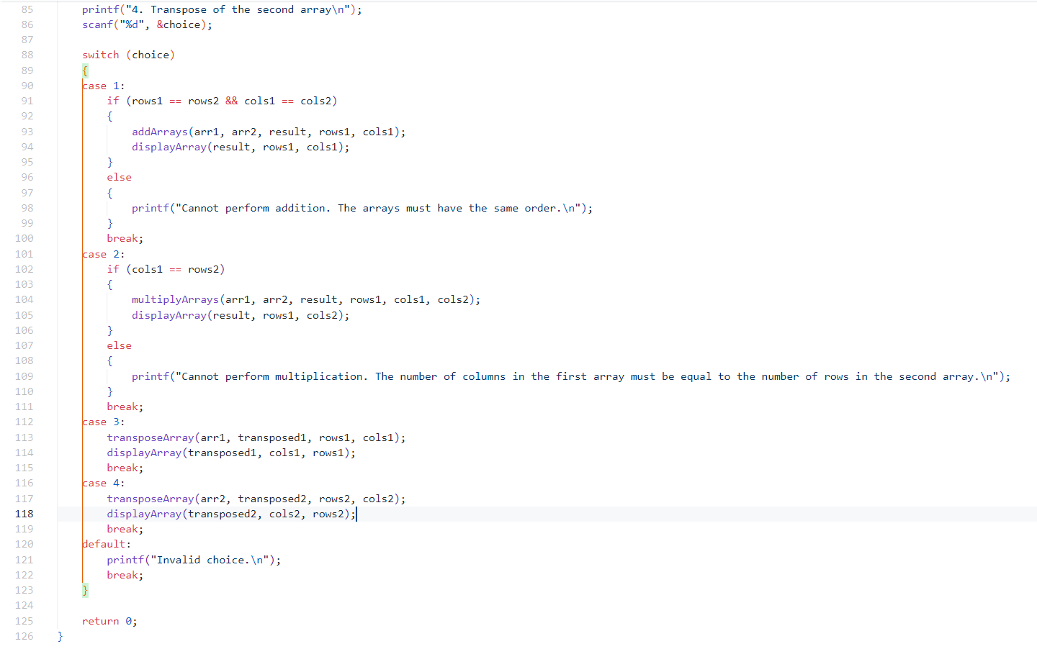

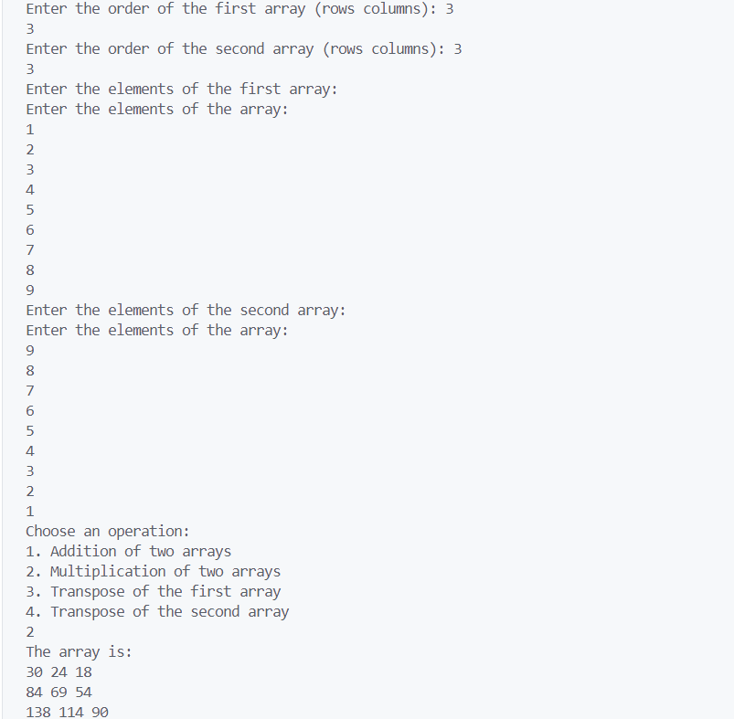

**Assignment 1:OUTPUT**

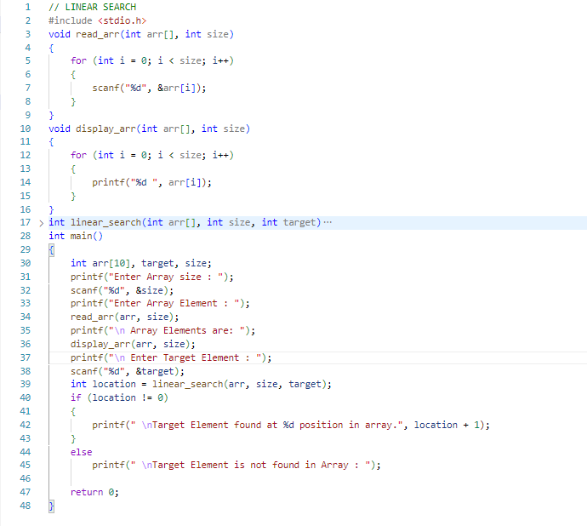

**Assignment 2 (A): IMPLEMENT LINEAR SEARCH**

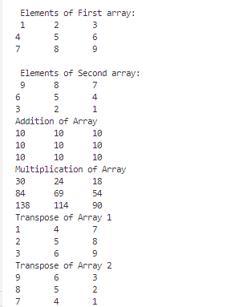

**Assignment 2 (A): OUTPUT**

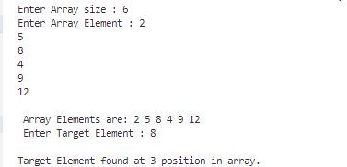

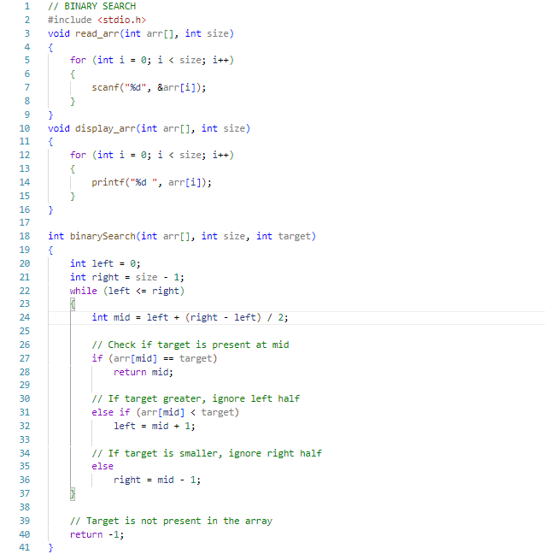

**Assignment 2 (B): IMPLEMENT BINARY SEARCH**

**Assignment 2 (B): IMPLEMENT BINARY SEARCH**

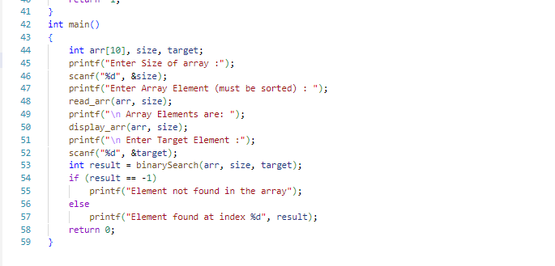

**Assignment 2 (B): OUTPUT**

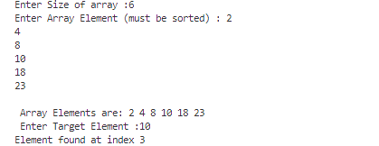

**Assignment 3: Implementation of Stack using arrays**

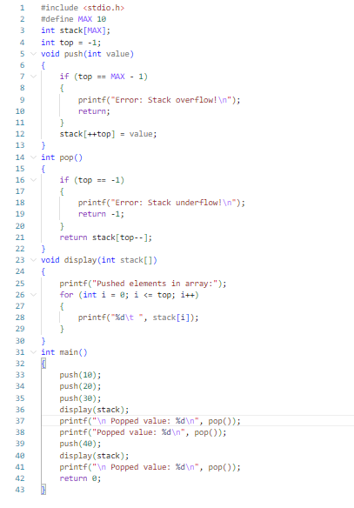

**Assignment 3: Output**



**Assignment 3: Implementation of Queue using arrays**

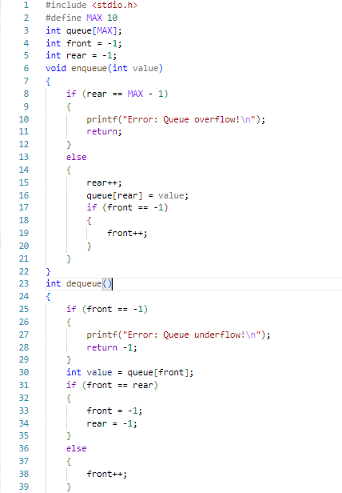

**Assignment 3: Implementation of Queue using arrays**

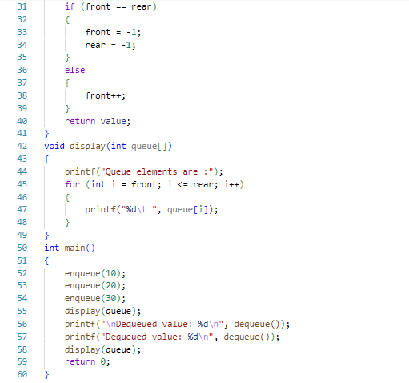

**Assignment 3: Output**



**Assignment 3: Implementation of Circular Queue using arrays**

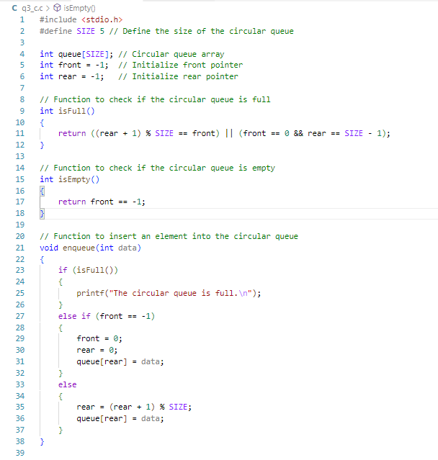

**Assignment 3: Implementation of Circular Queue using arrays**

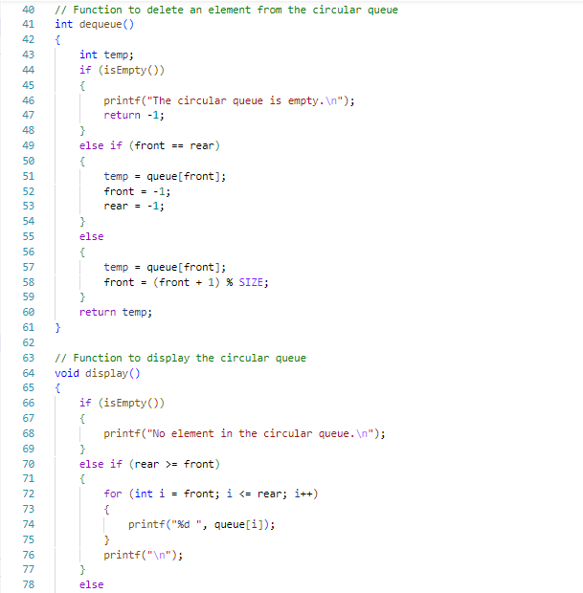

**Assignment 3: Implementation of Circular Queue using arrays**

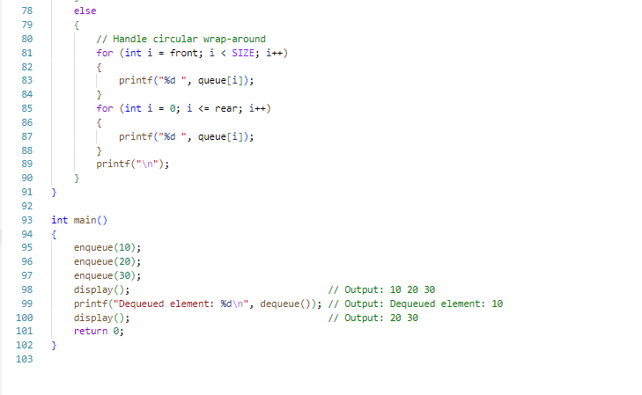

**Assignment 3: Implementation of Circular Queue using arrays**

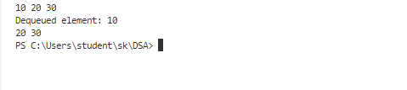

**Assignment 4: To Implement insert and delete operation in linked list**

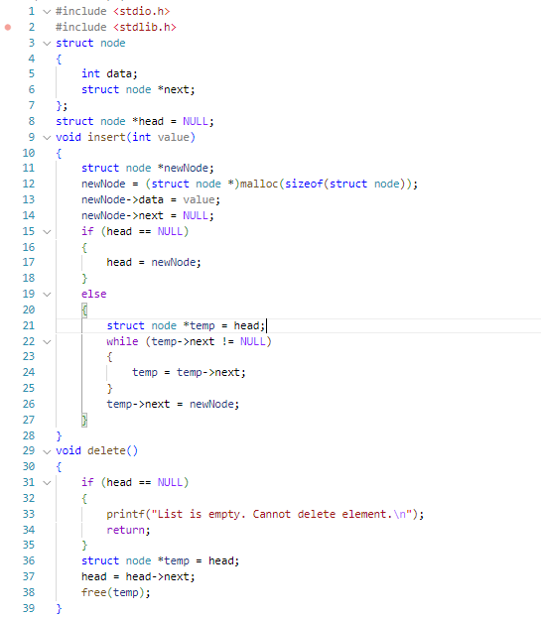

**Assignment 4: To Implement insert and delete operation in linked list**

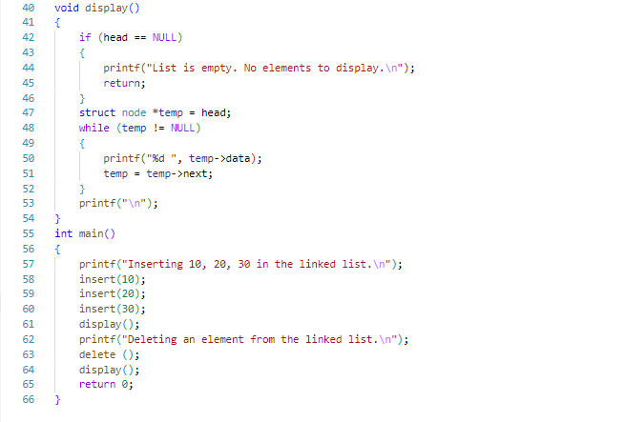

**Assignment 4: Output**

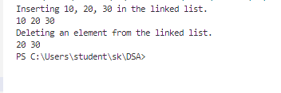

**Assignment 5(A): To implement Stack using Linked list**

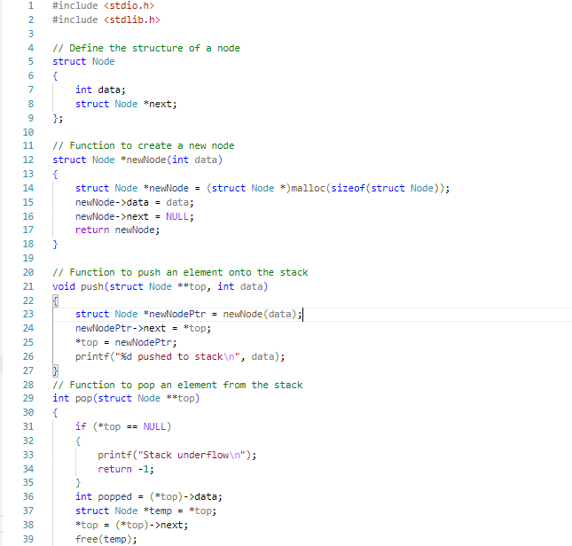

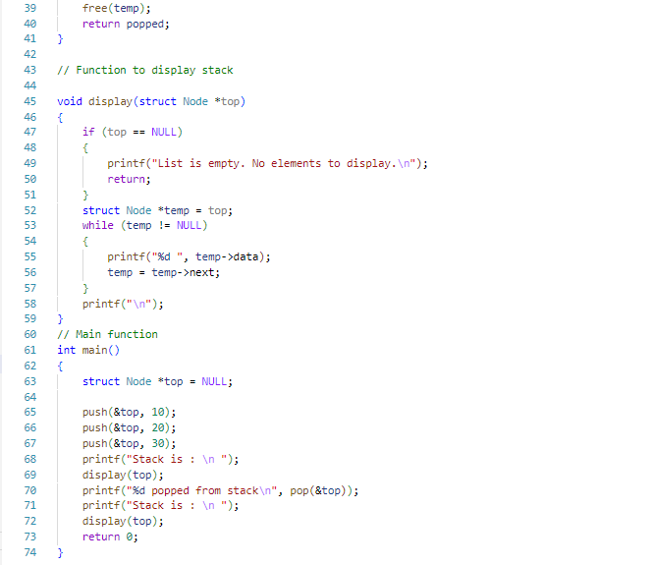

**Assignment 5(A): To implement Stack using Linked list**

**Assignment 5(A): OUTPUT**

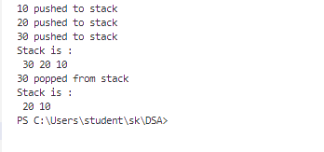

**Assignment 5(B): To implement Queue using Linked list**

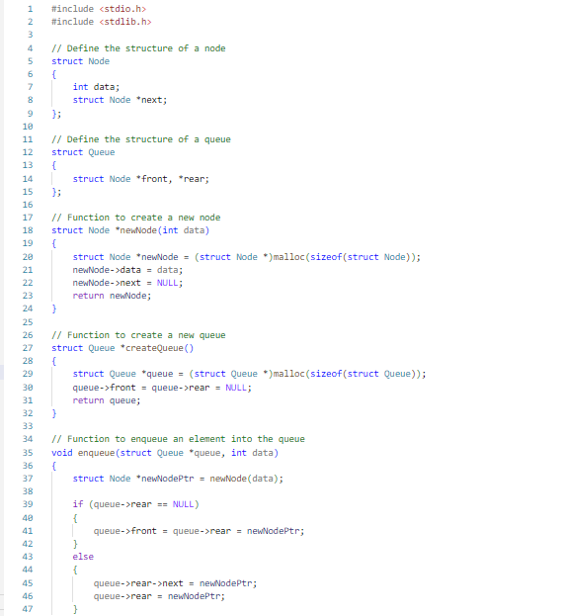

**Assignment 5(B): To implement Queue using Linked list**

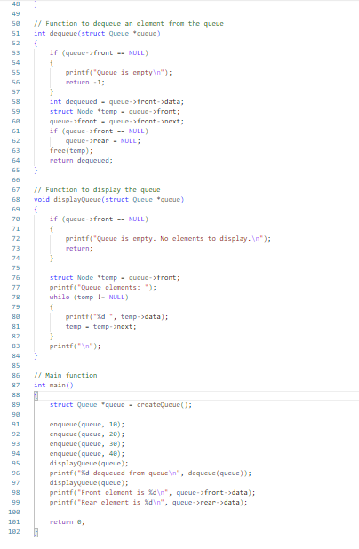

**Assignment 5(B): OUTPUT**

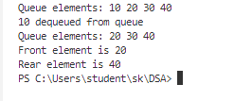

**Assignment 6(A): Implementation of Bubble Sort**

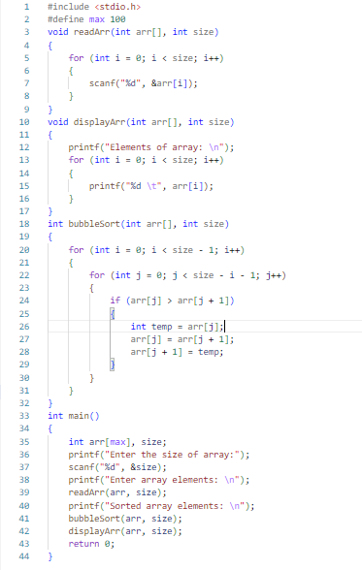

**Assignment 6(A): Output**

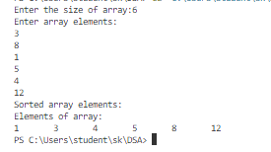

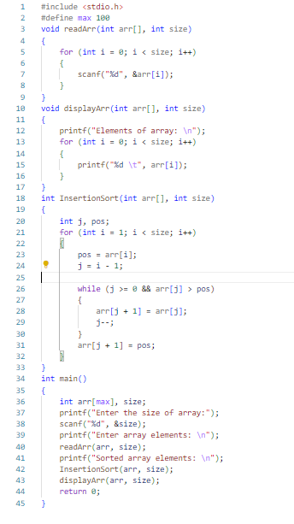

**Assignment 6(A): Implementation of Selection Sort**

**Assignment 6(A): OUTPUT**

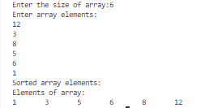

**Assignment 6(C): Implementation of Selection Sort**

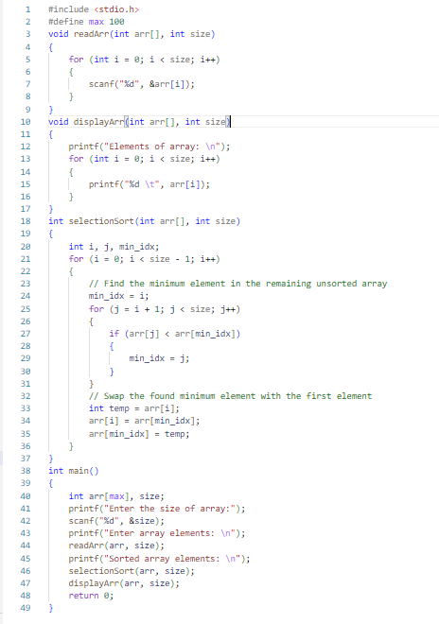

**Assignment 6(C): OUTPUT**

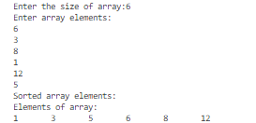

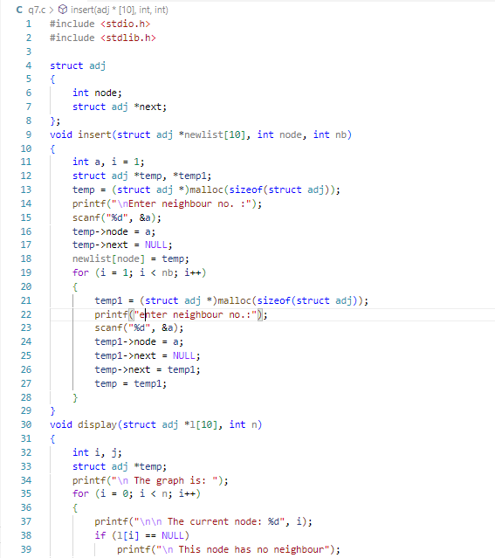

**Assignment 7: Implementation of Graph**

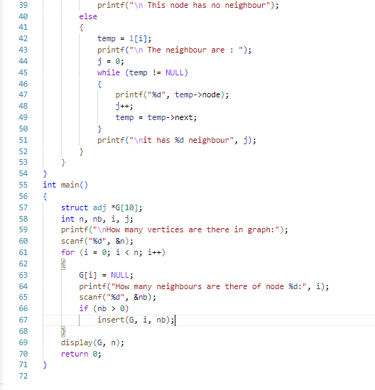

**Assignment 7: Implementation of Graph**

**Assignment 7: OUTPUT**

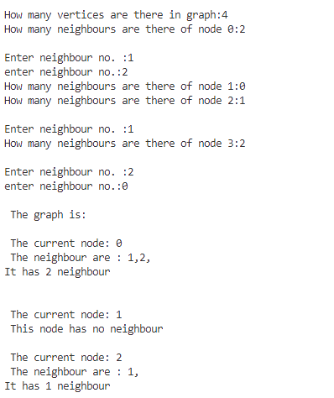

**Assignment 8(A): Implementation of BFS**

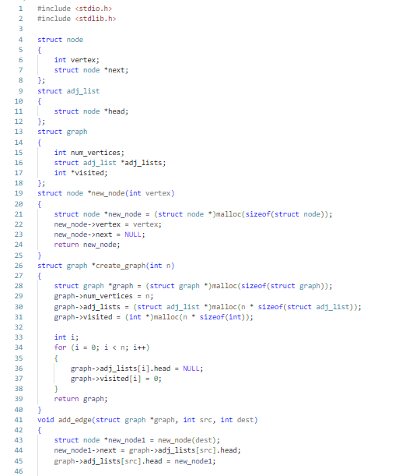

**Assignment 8(A): Implementation of BFS**

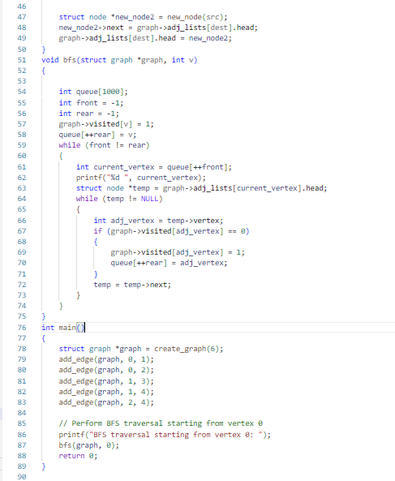

***OUTPUT :***



**Assignment 8(B): Implementation of DFS**

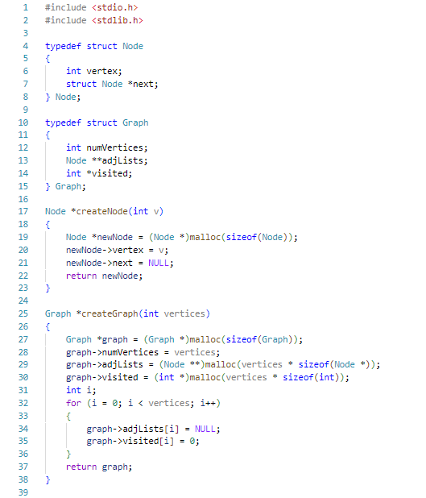



**Assignment 8(B): Implementation of DFS**

*** OUTPUT :***

**Assignment 9(A): Implementation of Merge sort**

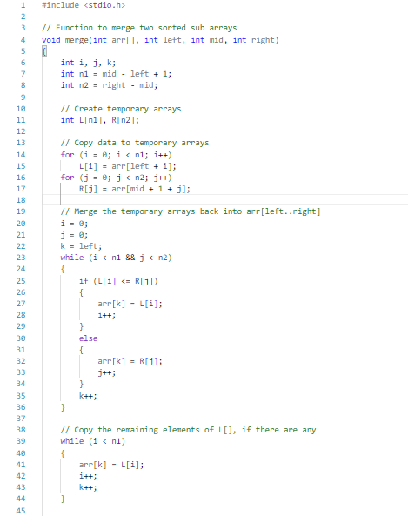

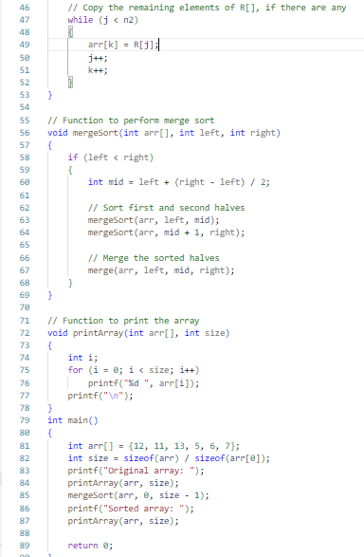

**Assignment 9(A): Implementation of Merge sort**

***OUTPUT :***



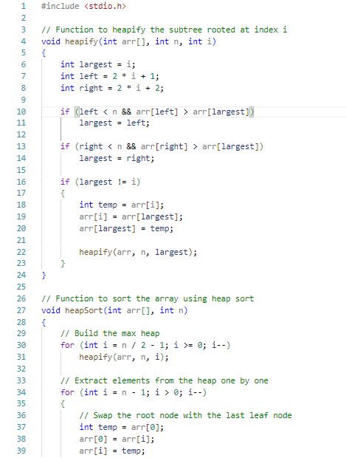

**Assignment 9(B): Implementation of Heap sort**

**Assignment 9(B): Implementation of Heap sort**

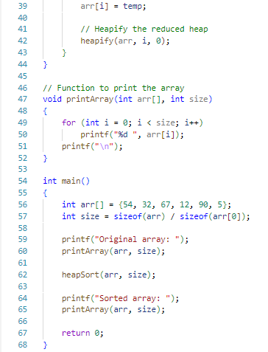

***OUTPUT :***



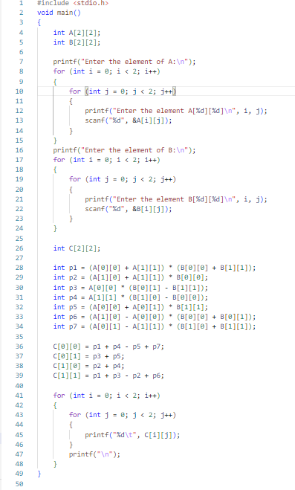

**Assignment 10: Implementation of matrix multiplication using Strassen’s algorithm**

**Assignment 10: OUTPUT**

